Omron Vision System
Index
Select the RUN mode for working. 2
Procedure to modified a measure. 2
Save parameter. 12
Copy program data. 13
Restore the original program. 14
Create a new program. 14

Select the RUN mode for working.

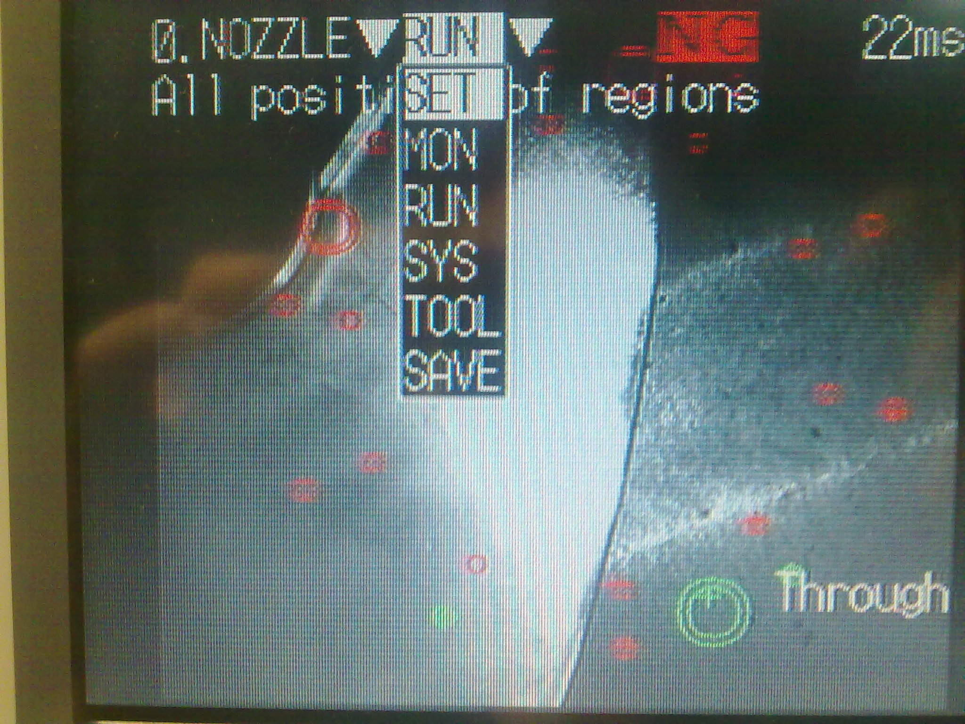

- Select RUN mode with the arrow key and press the “ENT” button.

Procedure to modified a measure.
- Switch off the welding machine.
- On the touch panel you select service mode ---> Welding position and press the start button on the panel.

- Select SET mode on the camera system.
- Press the “ENT” button.
- Select Measurement.
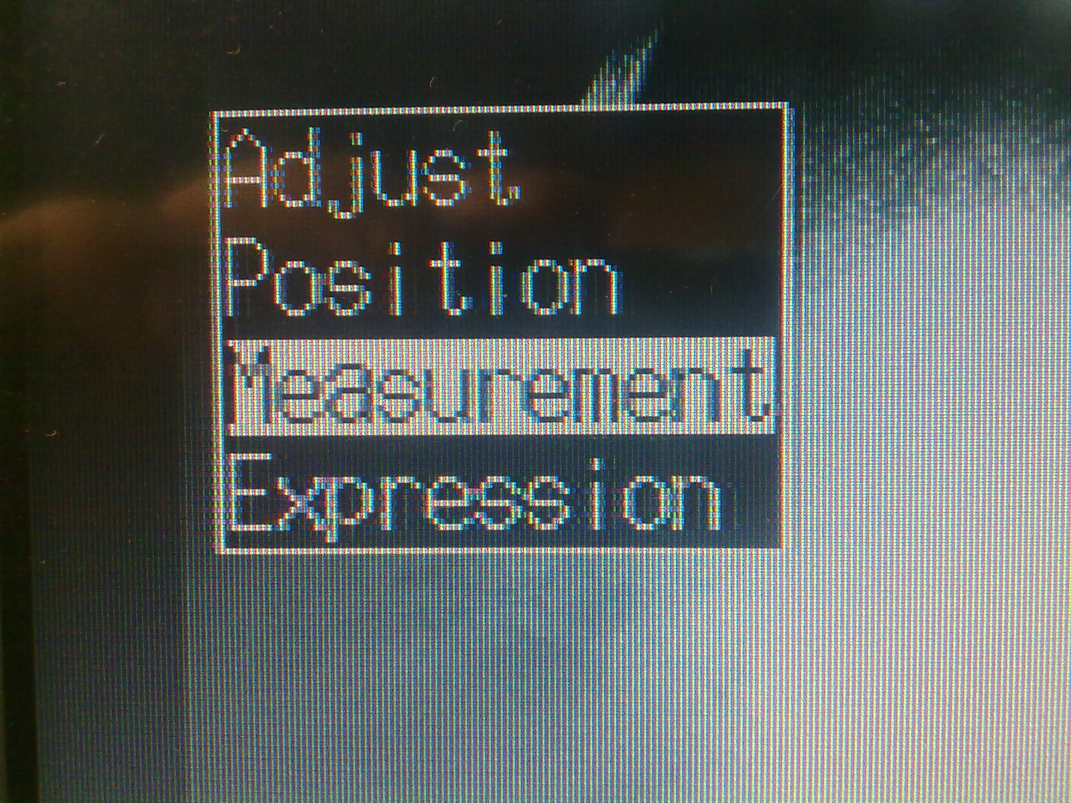
- Press the “ENT” button.
Type of measurement.
Gravity and area.
When a gravity and area measurement is used, an object will receive an OK judgement if the number of white pixels is the same as the OK setting.

- Now select the number of measurement.

From 0 to 9 : ARM check.
From 10 to 19 : PIN check.
From 20 to 22 : ROLLER check.

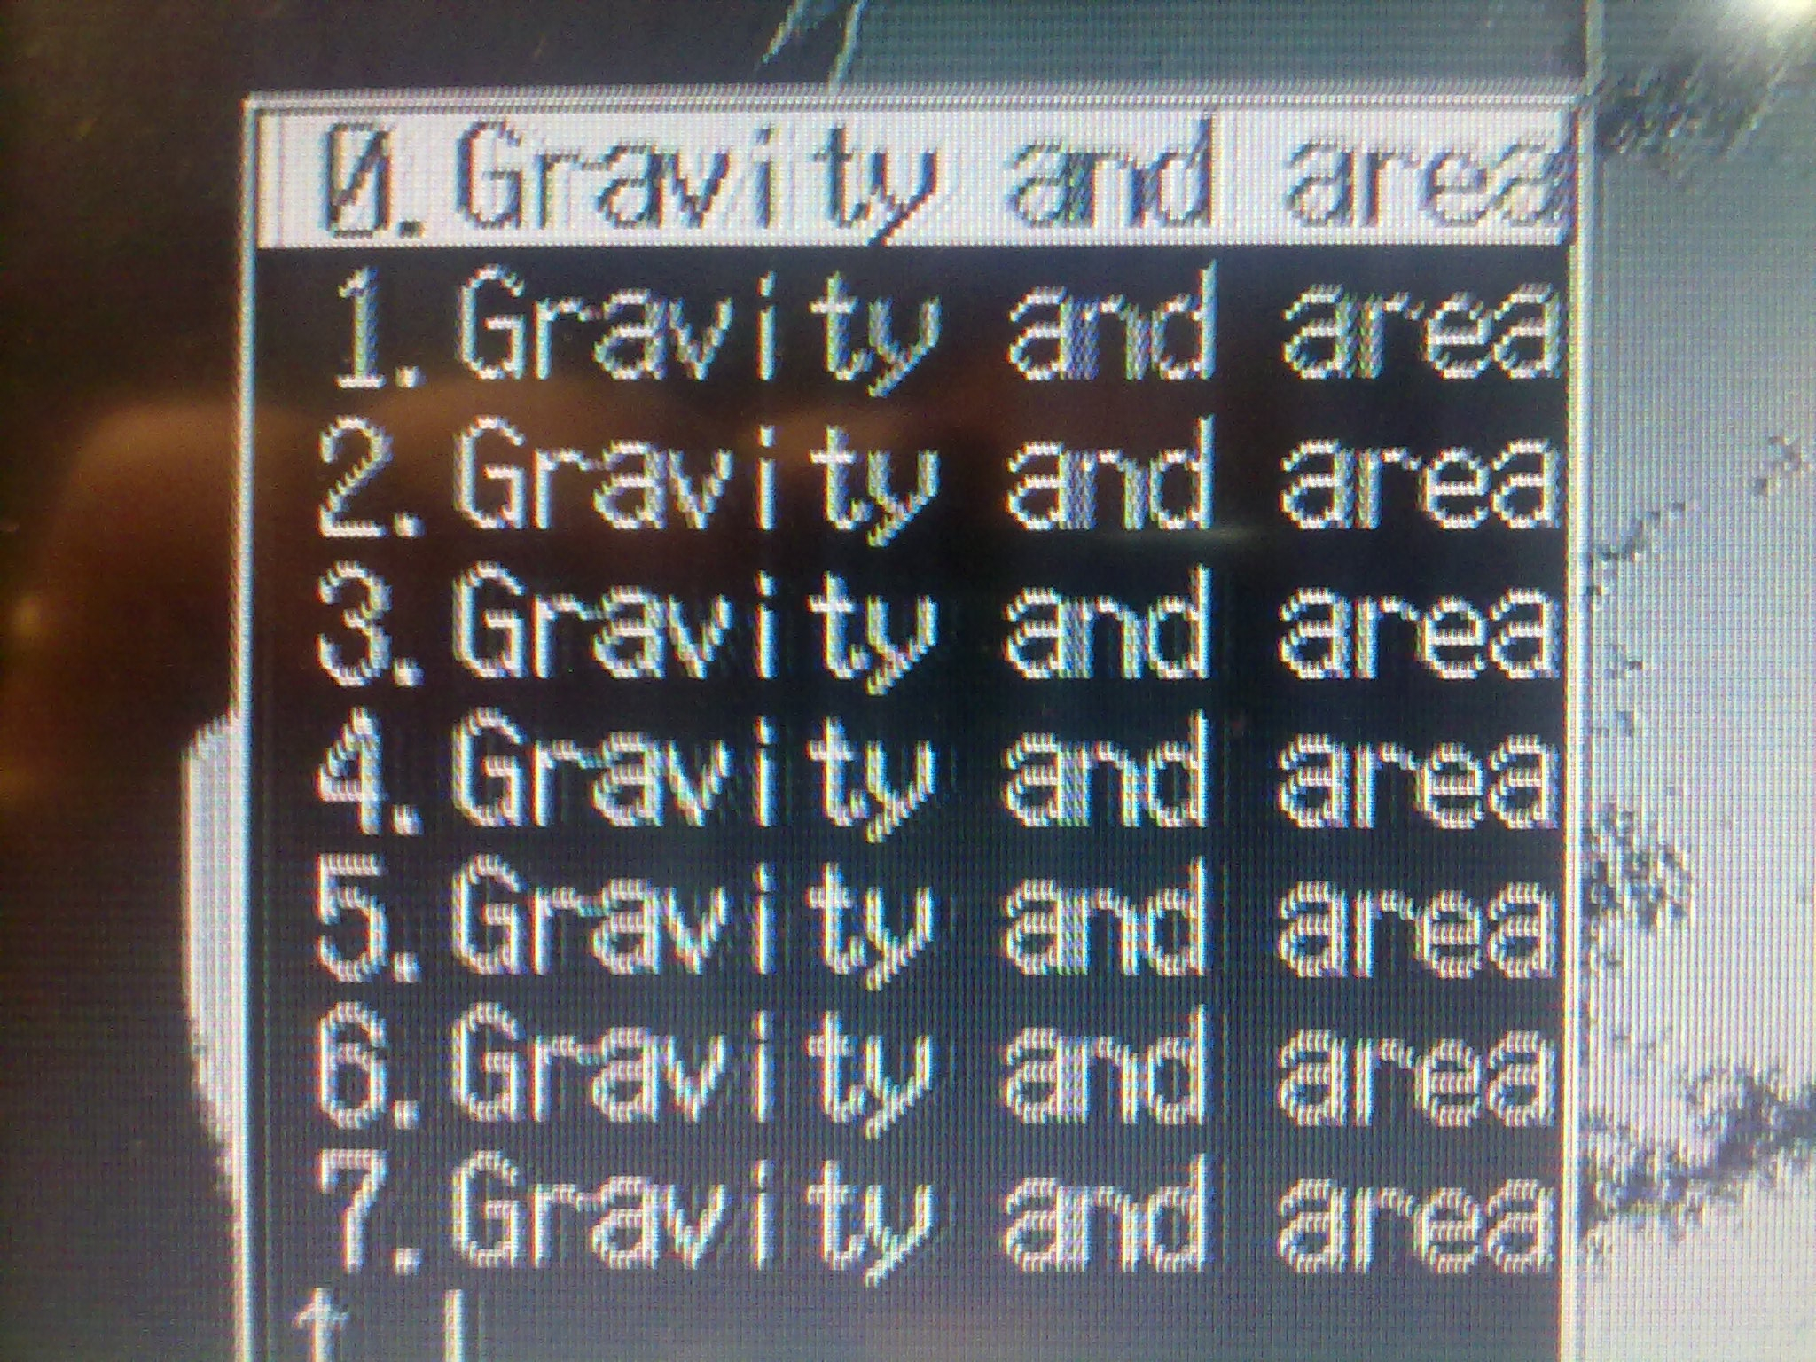
- Press the “ENT” button.
- For adjust the picture quality with the arrow keys Select “BINARY”.
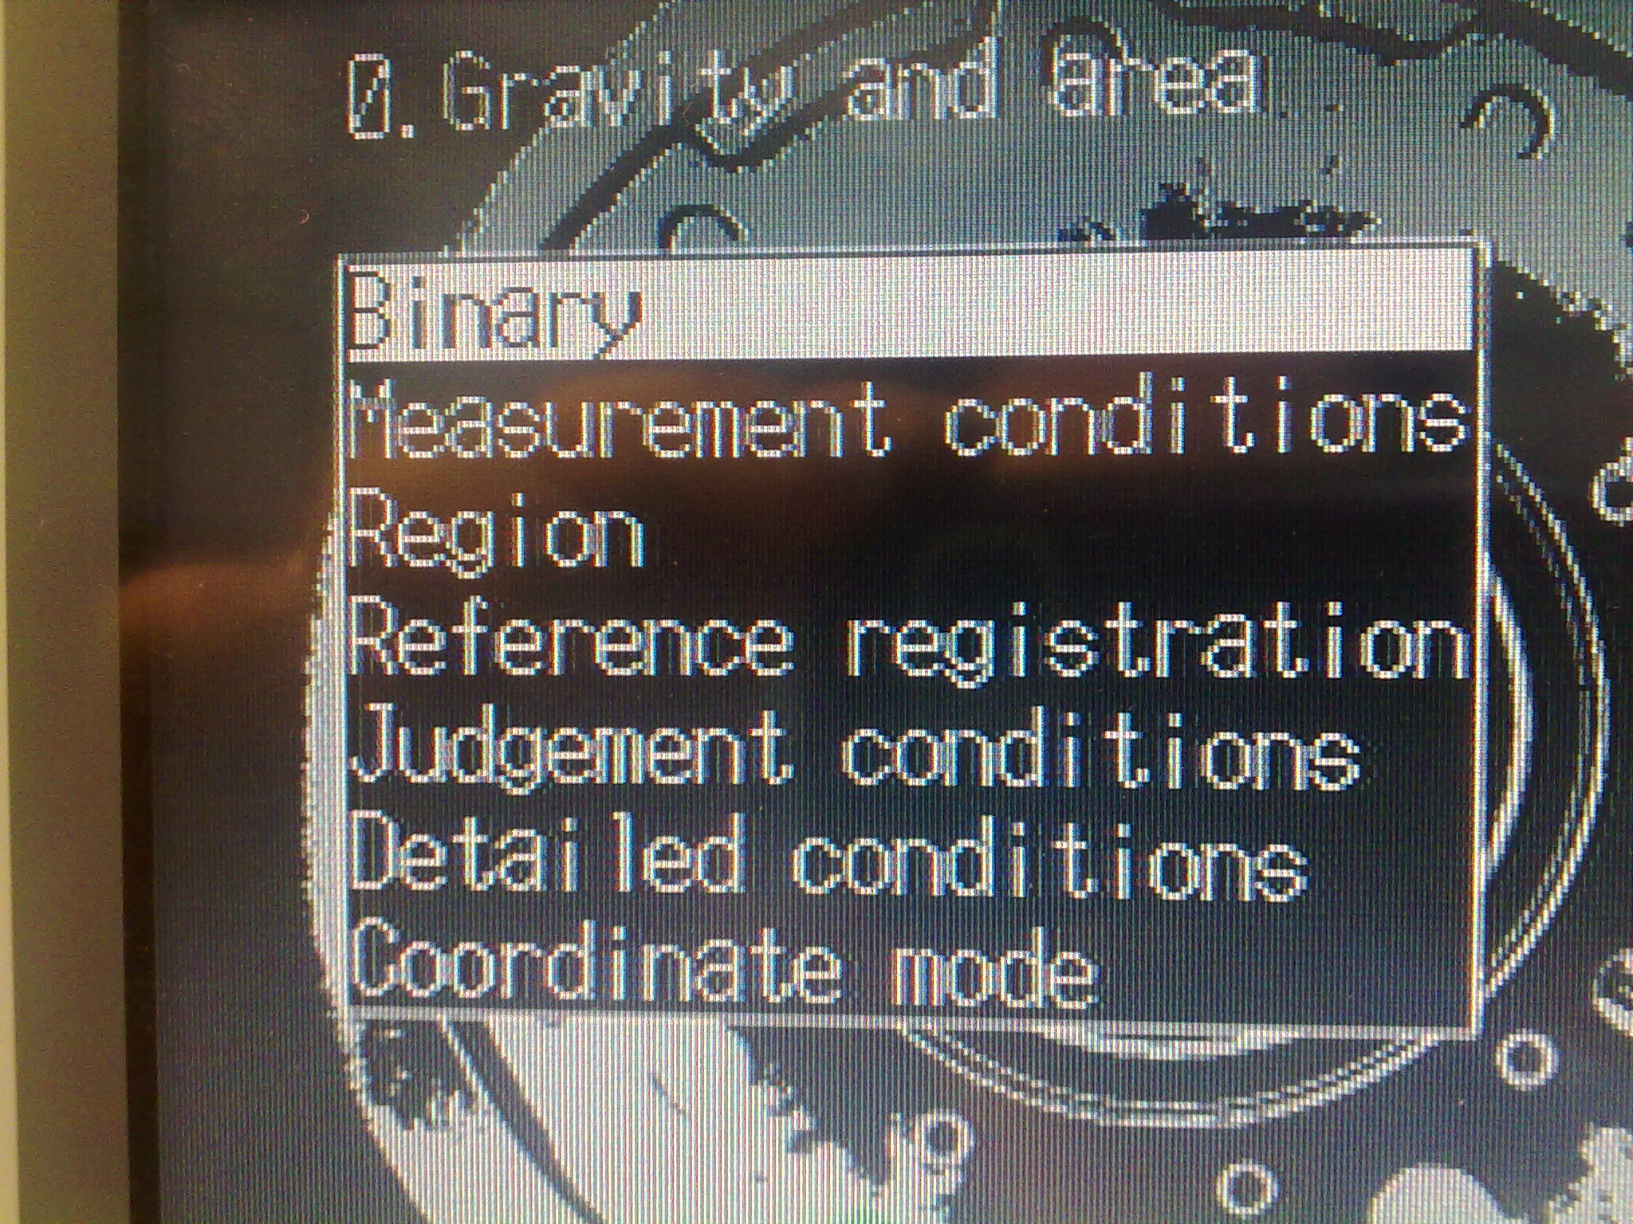

- Press the “ENT” button.
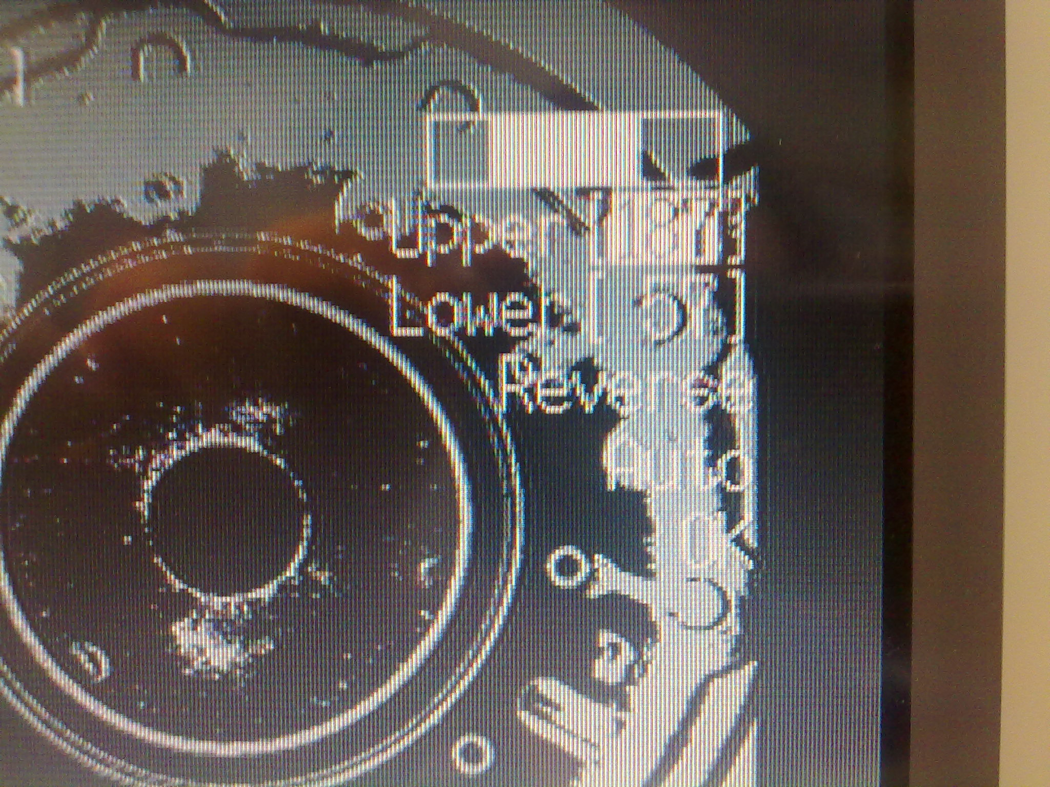

- With the arrow keys change the UPPER and LOWER value for adjust the picture. When you have finish select the OK menu.

- For adjust the correct figure ith the arrow keys Select “REGION”.
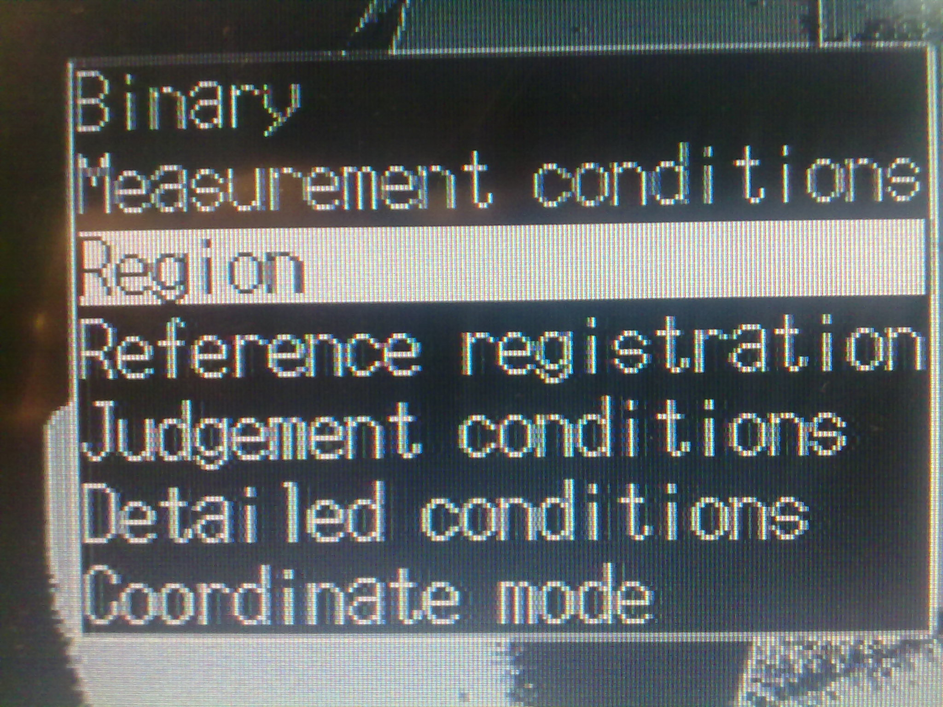

- Press the “ENT” button.
- With the arrow key select Figure0.
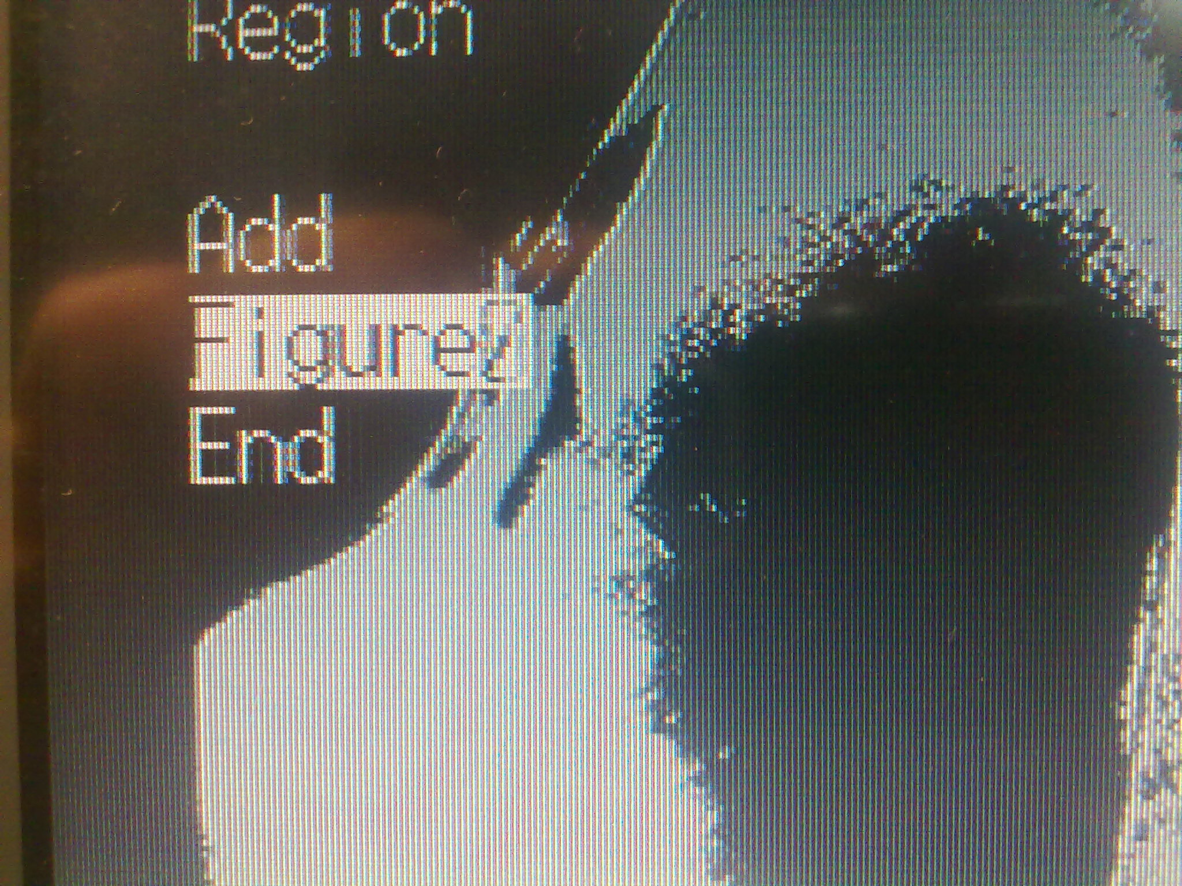

- Press the “ENT” button.
- Select “CORRECT” and press the “ENT” button.
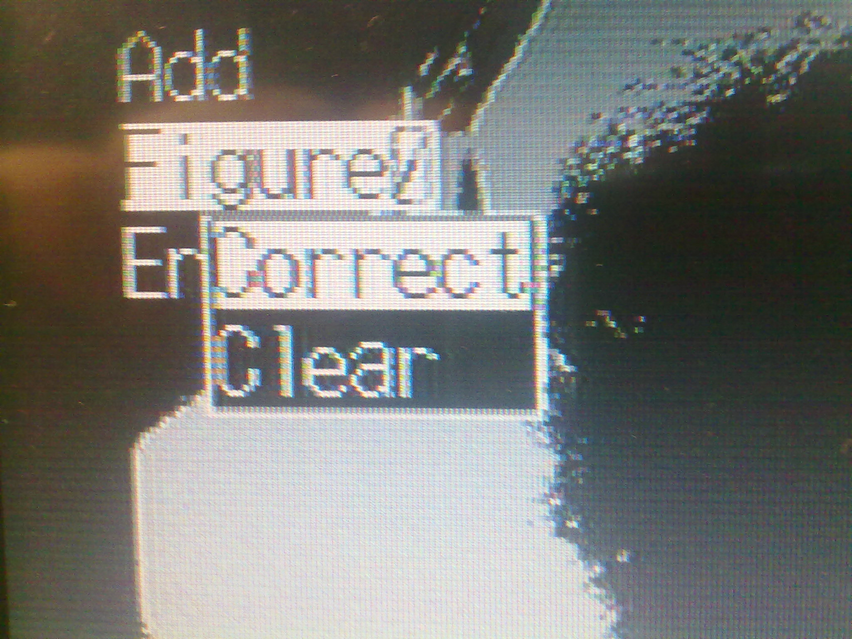
- Now with the arrow keys you can move the figure in the correct position. When you have finish press the “ENT” button and with the arrow keys now you can change the dimensions of the figure0. (You don't change the dimensions but just the position if it is not correct). When you have finish select “END” menu and press the “ENT” button.

- If the position of figure is correct you can change the judgment condition.
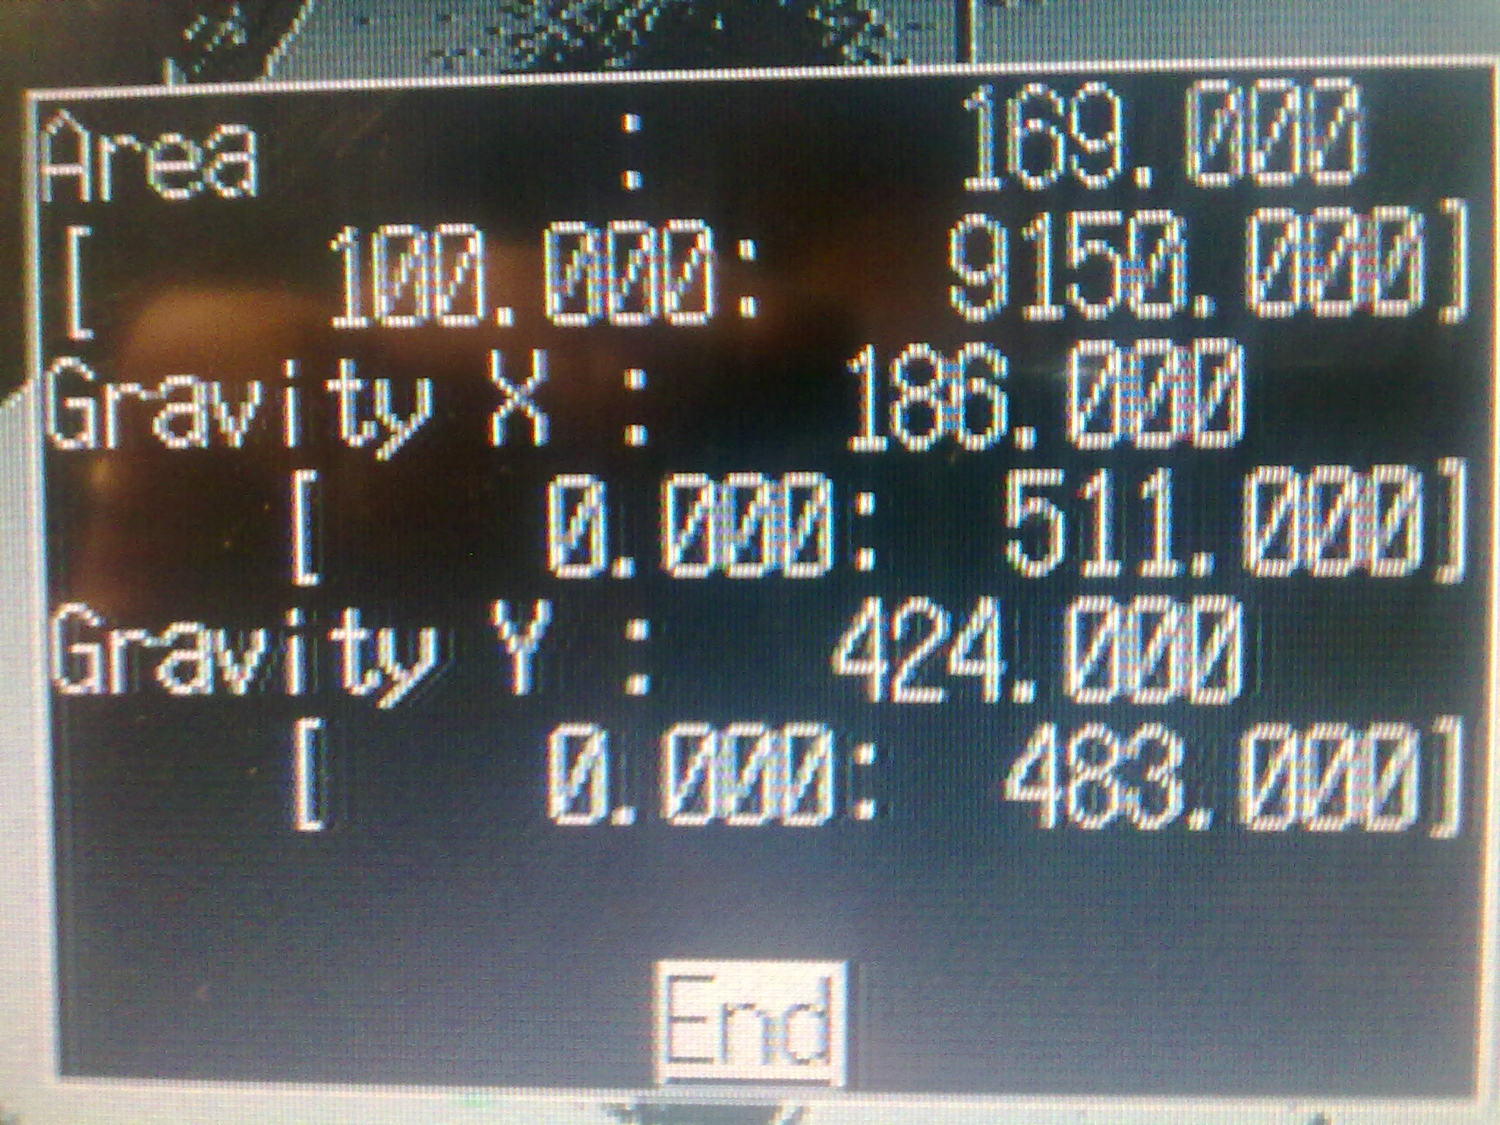
1
2
3
1) Current value.

2) Minimum value.

3) Maximum value.

When the current value(1) is between the minimum(2) and the maximum value(3), the measurement is correct when is less the minimum or great the maximum the measurement is bad.

- When you have finish, select the END and press the “ENT” button.

Save parameter.
Save settings to flash memory before turning the power OFF.

Precaution Flash memory data is loaded each time the vision system is started. Therefore, when settings have been changed, be sure to save then to flash memory before turning OFF the power. If the power is turned OFF without saving new settings,
all of the setting changes will be lost.

- Select “SAVE” button on the camera vision and press the “ENT” button.

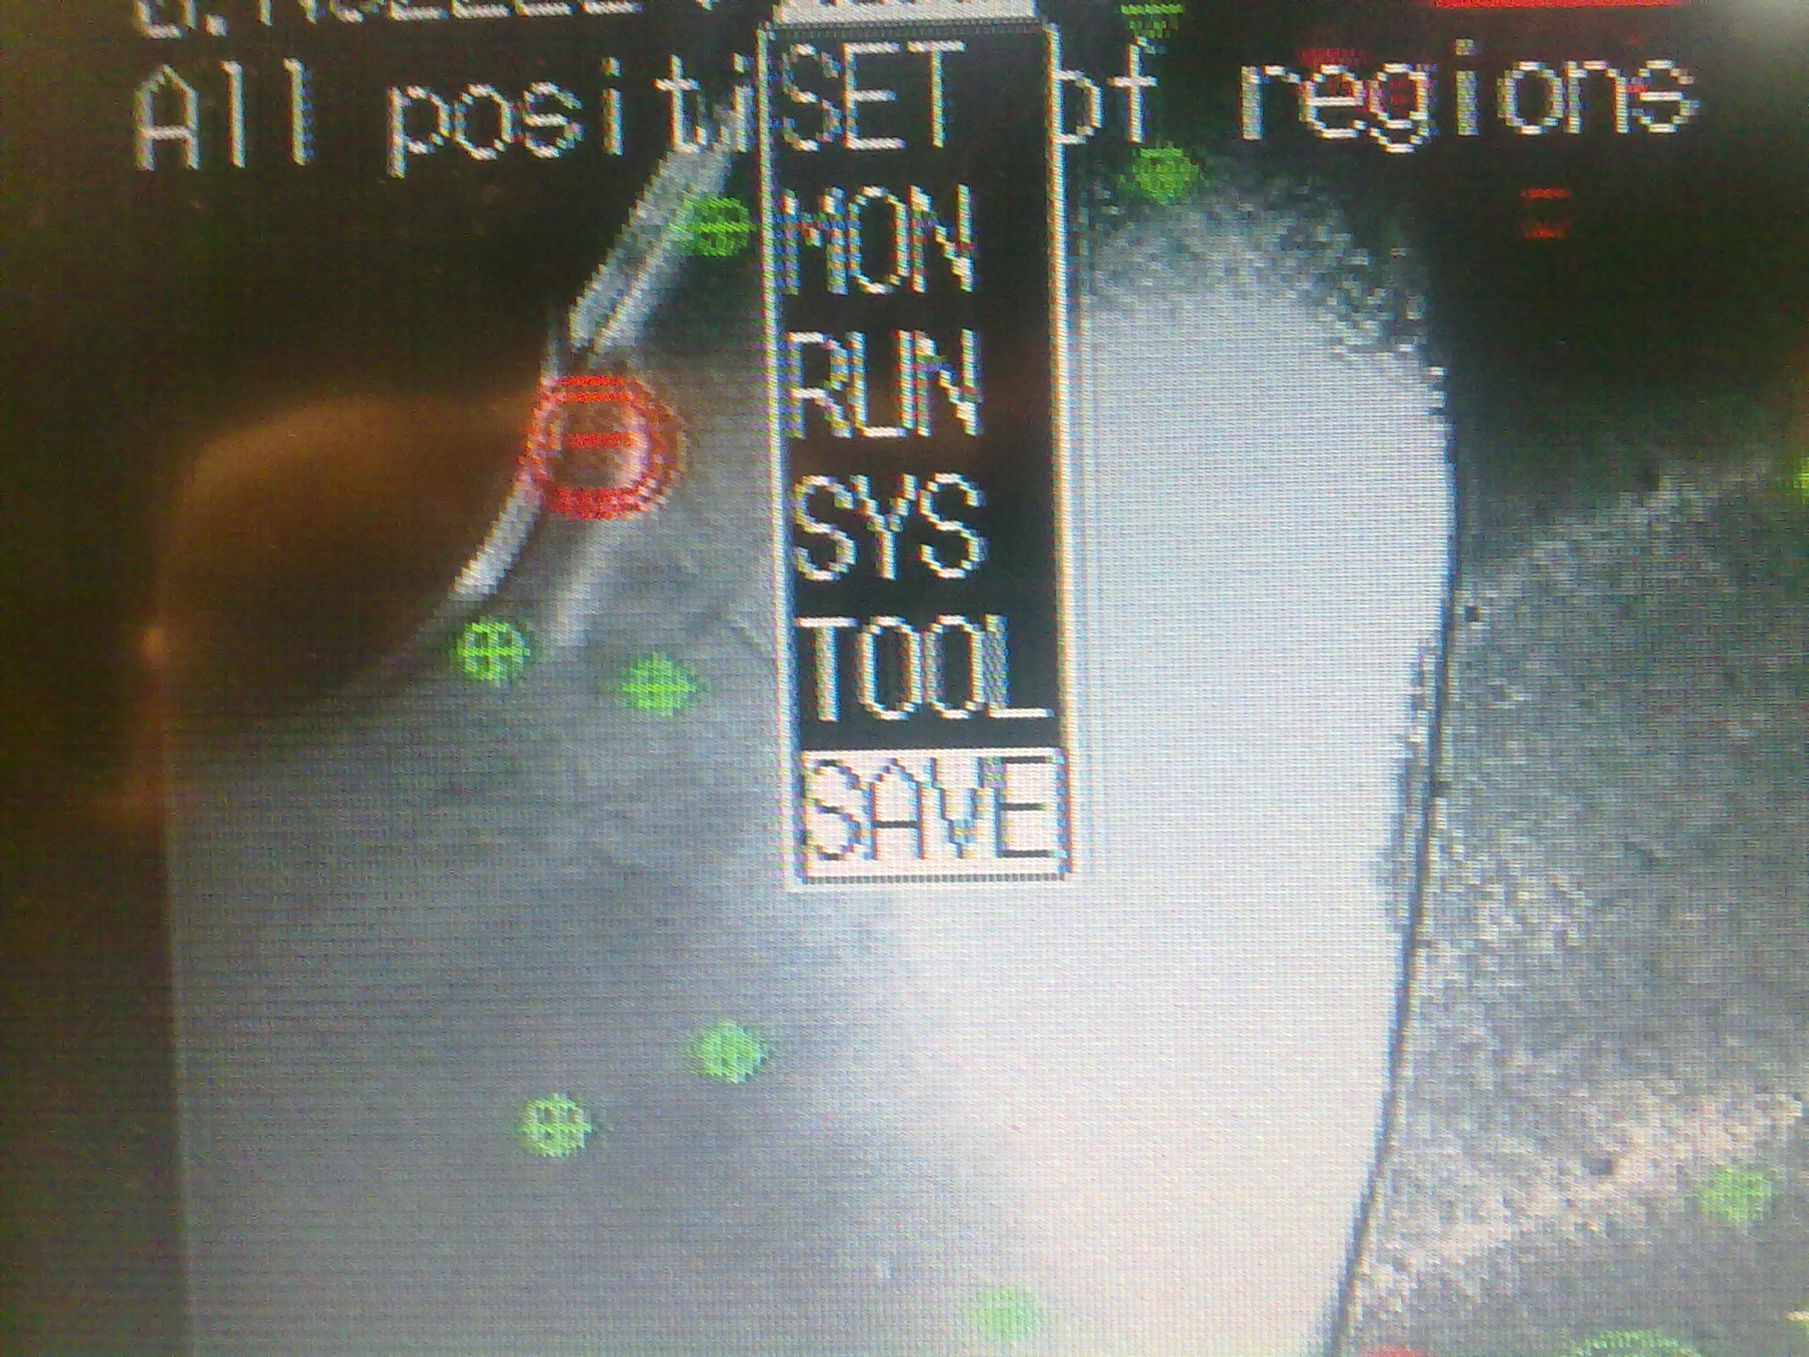

- Select whit the left arrow key “EXECUTE” and press the “ENT” button.
- Wait the finish.

Copy program data.

- Move the cursor to Scn and press the ENT Key.
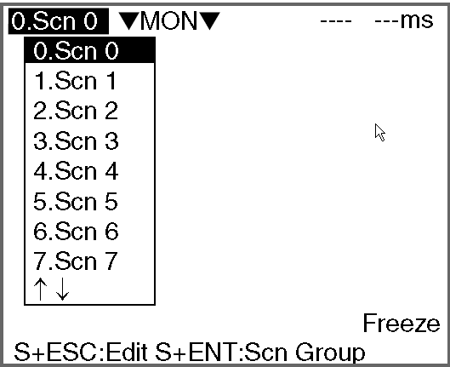
- Move the cursor to the scene number to be copied.
- Press the SHIFT+ESC Keys.
The Copy/Clear/Comment Menu will be displayed.
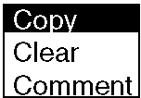

- Select Copy.
The screen for copying will be displayed.

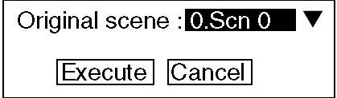

5. Enter the number of the scene to be copied (Original scene), and select
Execute.

The data will be copied.

Restore the original program.

If you want restored the original program you must copy the SCH31 on the SCH0. Refer to section “Copy program data”.

Create a new program.
- Select the number of program.
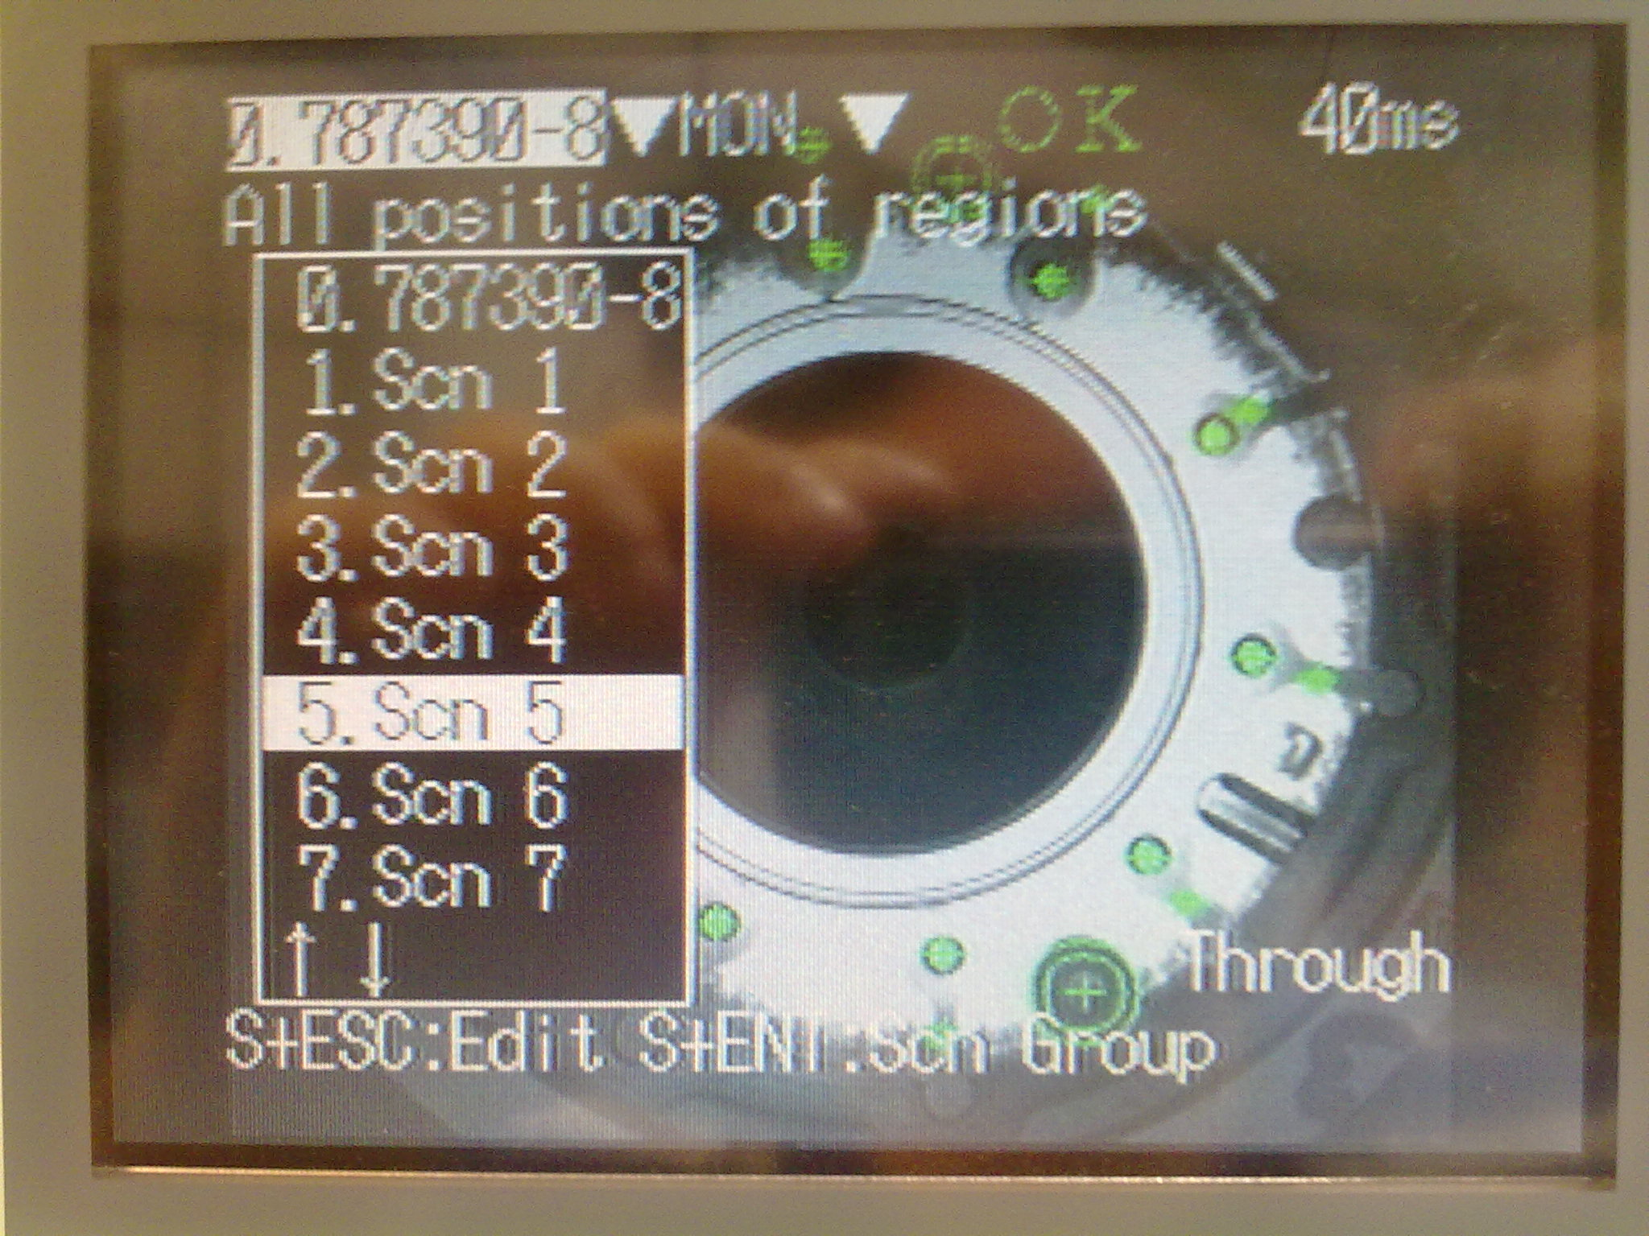
- Number 5 in this example and press the “ENT” button.
- Now select SET mode and press the “ENT” button.
- Select MEASUREMENT and press the “ENT” button.
- Select the number of misurement.
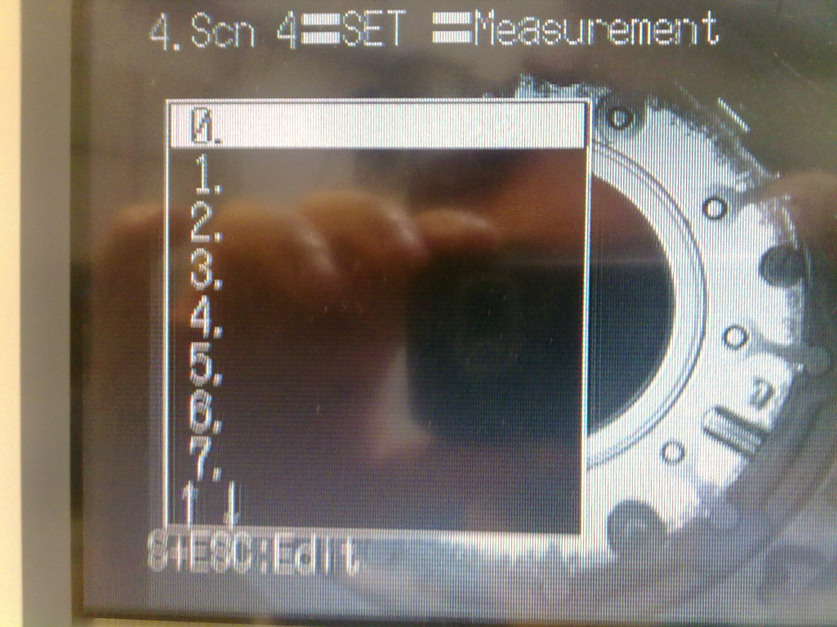
- Press the “ENT” button.
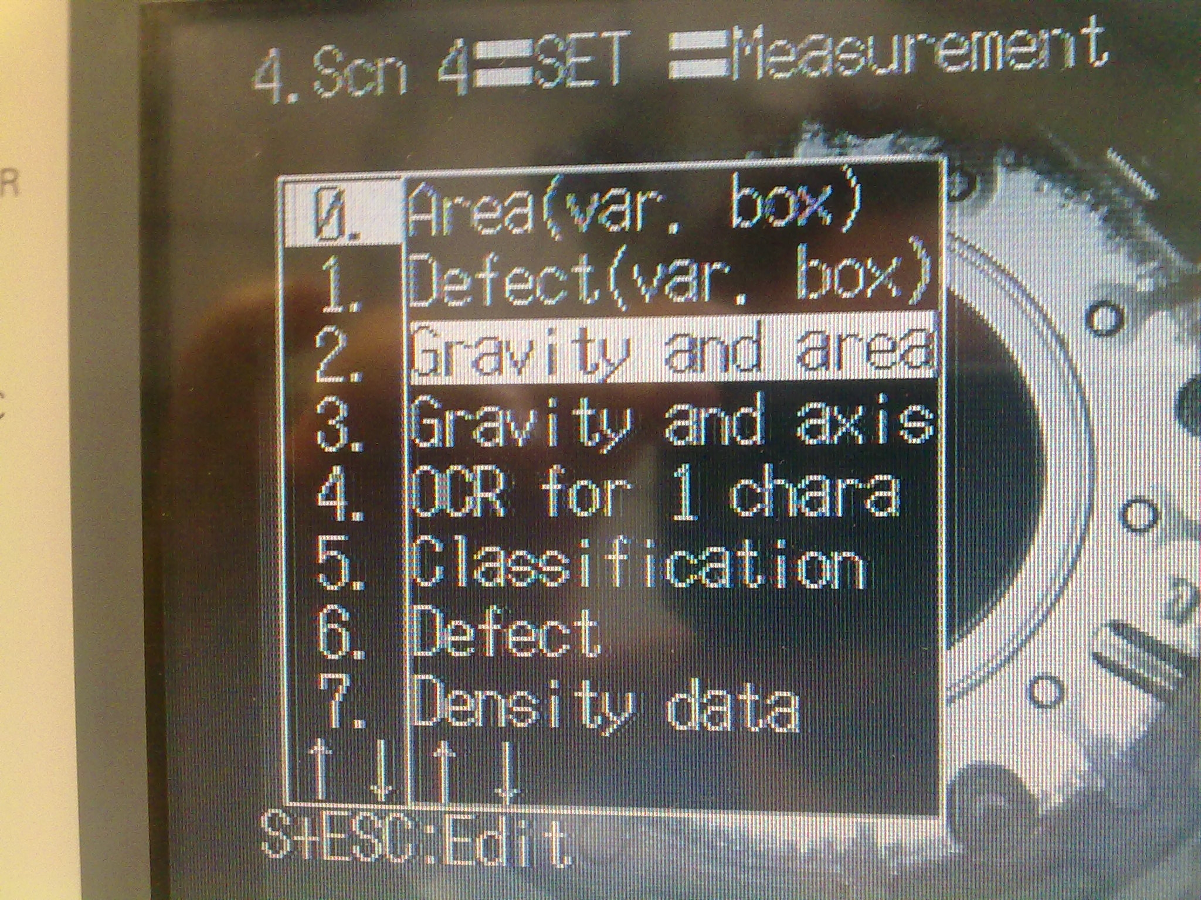
- Select Gravity and area and press the “ENT” button.
- Now select the measurement and press the “ENT” button, after select REGION.
- Select NEW ----> CIRCLE ---->OR. (see the figure)
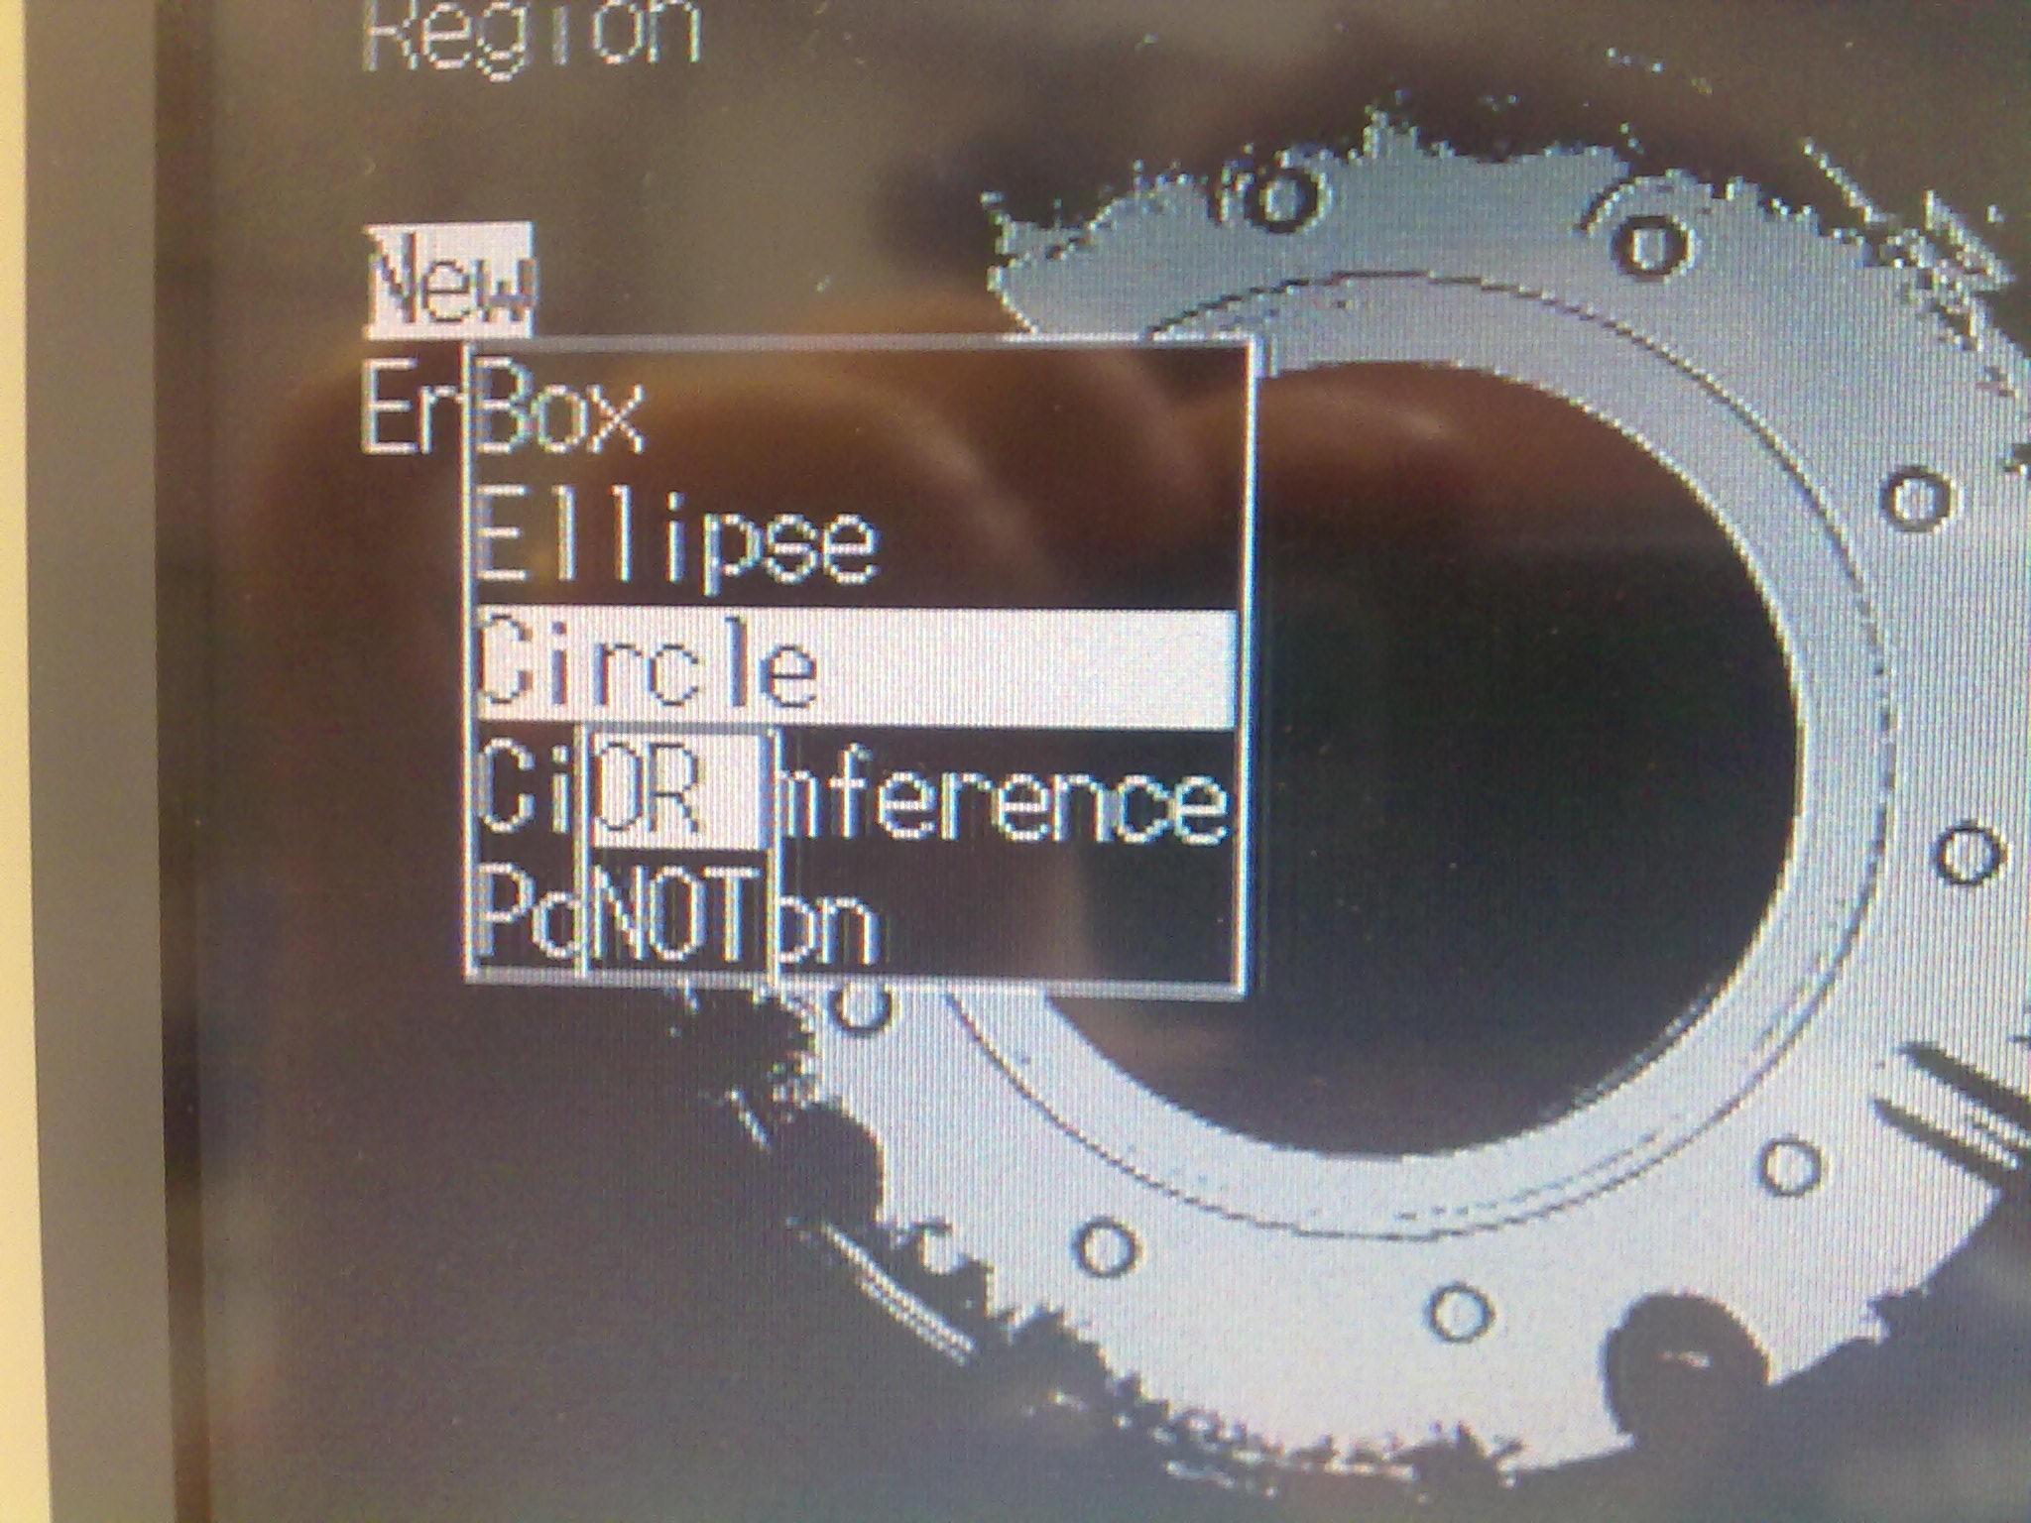
- Change the positions and the dimensions at the figure0 (see the “Procedure to modified a measure” section).
Can you repeat this part for all the measurement.

- After you have finish go on the menu SET ----> EXPRESSION ---->JUDGE
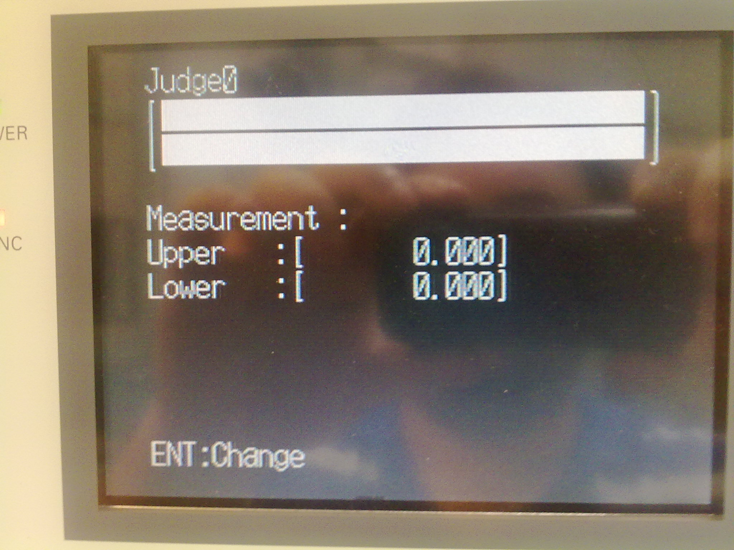
- Press the “ENT” button.
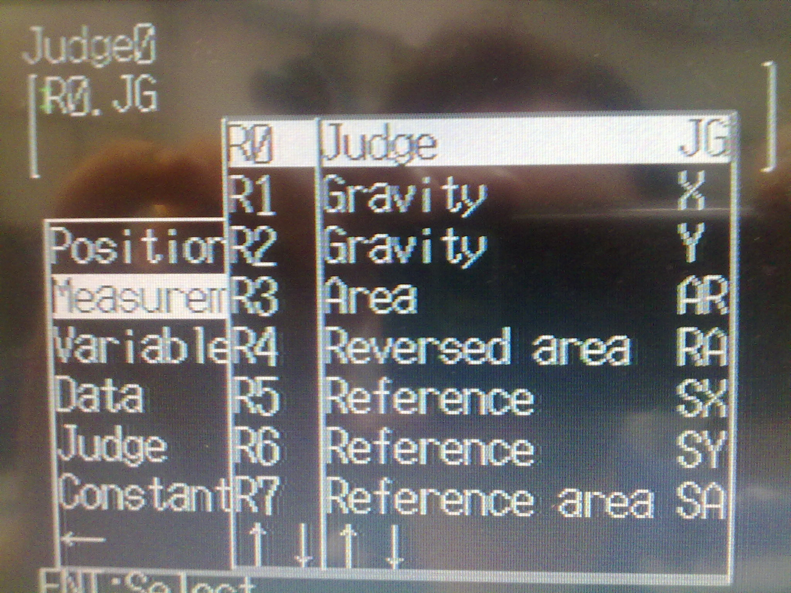
- Select Measurement ----> R0 ----> Judge and press the “ENT” button.
- After that select the OK button.

